
Introduction:
Over the past two decades, the world has witnessed rapid developments in wireless communication technologies and intelligent systems, which have contributed to the emergence of Intelligent Transportation Systems (ITS) as one of the most important technological solutions for addressing contemporary traffic challenges. This trend is part of the broader digital transformation that aims to integrate communication and information technologies into transportation infrastructure in order to achieve higher levels of efficiency, safety, and sustainability.
One of the most prominent technologies that emerged from this development is the Vehicular Ad Hoc Network (VANET), which is a dynamic wireless network that enables vehicles to communicate with each other (Vehicle-to-Vehicle – V2V) or with roadside infrastructure (Vehicle-to-Infrastructure – V2I) without requiring a fixed centralized architecture.
These networks enable the real-time exchange of vital information such as speed data, accident notifications, road conditions, and traffic signals, which contributes to reducing accidents, improving traffic management, and supporting autonomous vehicle applications. As reliance on this type of network increases, VANET has become a fundamental component of modern transportation systems.
However, the open nature of these networks, the rapid changes in their structure due to continuous vehicle movement, and their dependence on wireless communication make them vulnerable to a wide range of cyber threats and attacks. The possibility of new nodes joining the network instantly, along with data exchange without permanent centralized supervision, creates opportunities for attackers to inject false messages, launch denial-of-service attacks, or intercept transmitted data.
The seriousness of these threats lies in the fact that their impact is not limited to the informational aspect only, but may directly affect the safety of drivers and passengers, as well as critical transportation infrastructure. Sending false traffic information or disrupting warning systems may lead to serious accidents and human and material losses.
Accordingly, there is a clear need for an in-depth study of the security aspects of VANETs, an analysis of the potential vulnerabilities in their architecture and communication protocols, and an evaluation of the effectiveness of current protection mechanisms. This project aims to provide a scientific and analytical framework for studying security threats in VANETs by building a simulation environment, implementing selected attacks, and analyzing their impact on network performance, ultimately proposing defense solutions that enhance the reliability and security of these networks within modern intelligent transportation environments.

Scientific Problem :
With the significant development of intelligent transportation systems, Vehicular Ad Hoc Networks (VANETs) have become an important part of modern transportation infrastructure. These networks rely on direct wireless communication between vehicles and infrastructure and operate in a highly dynamic environment that continuously changes due to vehicle mobility and high speed.
The problem lies in the fact that the open nature of VANETs and the rapid exchange of data make them vulnerable to multiple cyberattacks such as identity spoofing, dissemination of false messages, and denial-of-service attacks. At the same time, applying strong security mechanisms may negatively affect network performance and response time, which is extremely critical in an environment that depends on instantaneous decisions related to traffic safety.
Therefore, the scientific problem is the need to study and analyze security vulnerabilities in VANETs, understand the impact of cyberattacks on network performance, and investigate protection mechanisms that can achieve a balance between security and performance efficiency.

Research Objective :
This research aims to study the security aspects of Vehicular Ad Hoc Networks (VANETs) by analyzing their architecture and communication patterns and identifying the most prominent vulnerabilities and attacks that may target them.
It also aims to build a suitable simulation environment to represent vehicle mobility and network communication, and to implement selected cyberattacks in order to study their impact on network performance indicators such as delay, packet loss, and throughput.
In addition, the research seeks to evaluate selected proposed protection mechanisms and attempt to reach solutions that achieve a balance between enhancing security and maintaining efficient network performance, thereby contributing to improving the reliability of VANETs within intelligent transportation systems.

State of the Art :
In the Field of VANET and V2X Security and Privacy
Vehicular Ad Hoc Networks (VANETs) have received increasing research attention in recent years due to their central role in Intelligent Transportation Systems (ITS) and autonomous vehicle applications. With the expansion of V2V, V2I, and V2X applications, security and privacy challenges have become a major focus of research.
First: Core Reference Studies (2021–2023)
Comprehensive Threat Analysis and Security Architecture Stage
Mahmoud et al. (2021):
This study provided a comprehensive review of security challenges in VANETs by analyzing attacks according to protocol layers (Physical, Network, Application). The study addressed attacks such as:
DoS
Sybil Attack
Replay Attack
Impersonation

It also focused on the system architecture (OBU, RSU, TA) and pointed out that the dynamic nature and rapidly changing topology are among the main weaknesses of VANETs.
Strength: Clear layered classification of attacks.
Gap: It did not provide intelligent solutions based on machine learning or advanced detection systems.
Yoshizawa et al. (2022/2023):
This study focused on analyzing the security and standardization aspects of V2X systems, especially in the European context (DSRC / ITS-G5 / C-ITS).
The study was distinguished by its analysis of:
Certificate management issues
Pseudonym change policies
Vulnerabilities in standard specifications

Strength: Deep standards-based analysis and comparison between American and European standards.
Gap: It focused on theoretical and standardization aspects without practical testing or performance simulation.
Second: Authentication and Privacy Enhancement Stage (2024)
Soujanya & Azam (2024):
This study presented an updated review of authentication mechanisms in VANETs, focusing on:
Authentication in V2V, V2I, and V2X
Blockchain technologies
Integration with 5G/6G networks
Resistance to attacks with computational cost analysis

Strength: Detailed comparison of authentication algorithms with performance analysis.
Gap: It remained within the scope of theoretical survey studies without a practical simulation environment.
Kesavan et al. (2024):
This study proposed an intrusion detection system, ML-CPIDS, that integrates:
Modern cryptographic protocols
Machine learning techniques for threat detection
Improved response time and reduced latency

Strength: Integration of cryptography with artificial intelligence.
Gap: It relies on pre-trained data, which may not fully reflect highly dynamic VANET environments.
Third: Recent Trends (2025)
Artificial Intelligence, Federated Learning, and Anomaly Detection
Borah & Paranjothi (2025):
This study proposed a false information attack detection model using unsupervised learning.
Its main advantages include:
No dependence on historical data
Reducing processing time by 30%
Lowering the false alarm rate by 17%

Strength: Real-time detection based on instantaneous network characteristics.
Gap: It focuses only on one type of attack, namely the False Information Attack.
Almansour et al. (2025):
This study proposed the APFed model for personalized federated learning using a lightweight LDwCBN network to detect intrusions in an Internet of Vehicles (IoV) environment.
Main features include:
Privacy preservation
Handling non-IID data issues
Improving accuracy by up to 5% compared with FedAvg

Strength: Suitable for dynamic IoV environments.
Gap: It requires distributed computing resources and supporting infrastructure.
Comparative Analysis of Research Trends :
The development of this field can be summarized into three main stages.
There is a gradual shift from traditional security solutions based mainly on cryptography toward intelligent solutions based on artificial intelligence.
However, there are still research gaps in:
Integrated performance evaluation under multiple attacks
Realistic simulation in highly dynamic VANET environments
Balancing security with response time and latency
Therefore, this project should address these research gaps through:
Combining the analysis of multiple attacks
Proposing an enhanced defense mechanism
Conducting practical testing within a simulation environment
Evaluating performance in terms of response time, attack detection rate, and resource consumption

This gives the project practical value that goes beyond purely theoretical survey studies.

Related Work Table :
Stage | Research Focus
2021–2022 | Threat analysis and attack classification
2023–2024 | Authentication enhancement  and the use of blockchain and  cryptography
2025 | Use of unsupervised  Learning and federated learning

There is a clear gradual shift from traditional security solutions based on cryptography toward intelligent solutions based on artificial intelligence. However, several research gaps still remain, particularly in the following areas:
integrated performance evaluation under multiple attacks
realistic simulation in highly dynamic VANET environments
balancing security with response time and latency.

Therefore, this project aims to address these research gaps by:
combining the analysis of multiple attacks
proposing an enhanced defense mechanism
conducting practical testing within a simulation environment
evaluating performance in terms of response time, attack detection rate, and resource consumption.

This gives the project practical value that goes beyond purely theoretical survey studies.

Detailed Related Work Table :
Relation to the Project | Results | Topic | Year | Article
Provides a theoretical foundation for analyzing security vulnerabilities in VANETs within the project | Detailed classification of DoS, Sybil, Replay, and Impersonation attacks, along with analysis of dynamic network characteristics | Comprehensive analysis of security challenges in VANETs and classification of attacks according to protocol layers | 2021 | Security in Vehicular Ad Hoc Networks: Challenges and Countermeasures
Supports the study of standard-related and structural vulnerabilities | Identified vulnerabilities in certificate management and pseudonym mechanisms | Security and standards analysis of V2X systems and European/American standards | 2022 | A Survey of Security and Privacy Issues in V2X Communication Systems
Strengthens the theoretical aspect of risk analysis | Presented the main security challenges and their impact on intelligent transportation systems | Security analysis of communication in V2X networks | 2022 | Security in V2X Systems
Helps in analyzing regulatory and organizational vulnerabilities | Identified causes of shortcomings and proposed recommendations for improvement | Analysis of the roots of privacy and security issues in standard frameworks | 2023 | A Survey of Security and Privacy Issues in V2X
Supports the study of identity management vulnerabilities | Analyzed pseudonym change policies and their effect on security | Identity and privacy management in vehicular networks | 2023 | Privacy & Identity Management in VANET
Provides a reference for developing an improved authentication mechanism | Detailed comparison of authentication mechanisms and efficiency analysis | Review of authentication mechanisms and integration of Blockchain and 5G/6G | 2024 | Ensuring Security and Privacy in VANET: Authentication Approaches
Supports the design of an intelligent defense mechanism | Improved response time and increased detection accuracy | Development of an intrusion detection system combining cryptography and machine learning | 2024 | Intrusion Detection System using ML-based Cryptographic Protocols
A reference for project performance evaluation | Improved threat detection efficiency and reduced delay | Machine learning-based intrusion detection model supported by cryptography | 2024 | ML-CPIDS in VANET (Scientific Reports)
Can be utilized in the simulation phase | Reduced processing time and false alarm rate | Detection of false information attacks using unsupervised learning | 2025 | Enhancing VANET Security: Unsupervised Learning Approach
Supports the development of a distributed defense model | Improved accuracy compared with traditional methods | Federated learning-based intrusion detection system | 2025 | Adaptive Personalized Federated Learning for IDS in IoV

Although several VANET attacks are discussed in the theoretical review, the practical implementation in this project focuses mainly on Identity Spoofing attacks and their detection and mitigation.

Chapter One: Theoretical Studies

Mechanism of VANET Networks

Vehicular Ad Hoc Networks (VANETs) are considered one of the advanced types of wireless networks, specifically designed to support Intelligent Transportation Systems (ITS). These networks aim to enhance road safety, reduce traffic accidents, and improve transportation efficiency by enabling real-time communication between vehicles and their surrounding environment.

The working mechanism of VANETs is based on the concept of ad hoc networking, where no fixed centralized infrastructure is required. Instead, each vehicle acts as an intelligent node within the network. These nodes are capable of sending, receiving, and forwarding data to other vehicles, forming a highly dynamic and continuously changing network.

- Components of VANET

VANETs consist of several key components that work together to ensure efficient communication:

Vehicles:

Vehicles represent the main nodes in the network. Each vehicle is equipped with wireless communication devices and sensors such as GPS, enabling it to determine its location and share relevant information.

Road Side Units (RSUs):

These are fixed devices installed along roads or at intersections. RSUs act as intermediaries between vehicles and infrastructure, and they help extend the network coverage.

On-Board Unit (OBU):

This unit is responsible for processing data within the vehicle and managing communication operations.

- Types of Communication in VANET

VANET supports different communication types, including:

Vehicle-to-Vehicle (V2V):

In this type, vehicles communicate directly with each other without the need for an intermediary. It is mainly used for safety applications such as collision warnings or sudden braking alerts.

Vehicle-to-Infrastructure (V2I):

Vehicles communicate with infrastructure components such as RSUs or smart traffic signals to obtain information about road conditions or traffic congestion.

Vehicle-to-Everything (V2X):

This is a broader concept that includes communication with vehicles, infrastructure, pedestrians, and smart devices.

- Data Exchange Mechanism
Vehicles in VANET exchange two main types of messages:
Periodic Messages:

These are sent continuously and include information such as position, speed, and direction.
Event-driven Messages:

These are generated when a specific event occurs, such as an accident or sudden traffic congestion.
These messages are transmitted using IEEE 802.11-based vehicular wireless communication in ad hoc mode, which supports dynamic communication in high-mobility vehicular environments.

- Routing in VANET

Due to the highly dynamic nature of VANET, routing is considered one of the major challenges. Specialized routing protocols are used to handle the frequent changes in network topology.

These protocols include:

Geographic-based routing protocols

Topology-based routing protocols

The selection of the best path depends on factors such as vehicle location and current network conditions.

- Role of Positioning Technologies

VANET heavily relies on positioning systems such as GPS. These systems play a critical role in:

Improving routing efficiency

Reducing data loss

Supporting real-time applications

- Characteristics of VANET Operation

The operation of VANET is characterized by several key features:

Highly dynamic network topology

Lack of fixed infrastructure

Real-time communication requirements

Strong dependence on geographic location
VANET Architecture Diagram

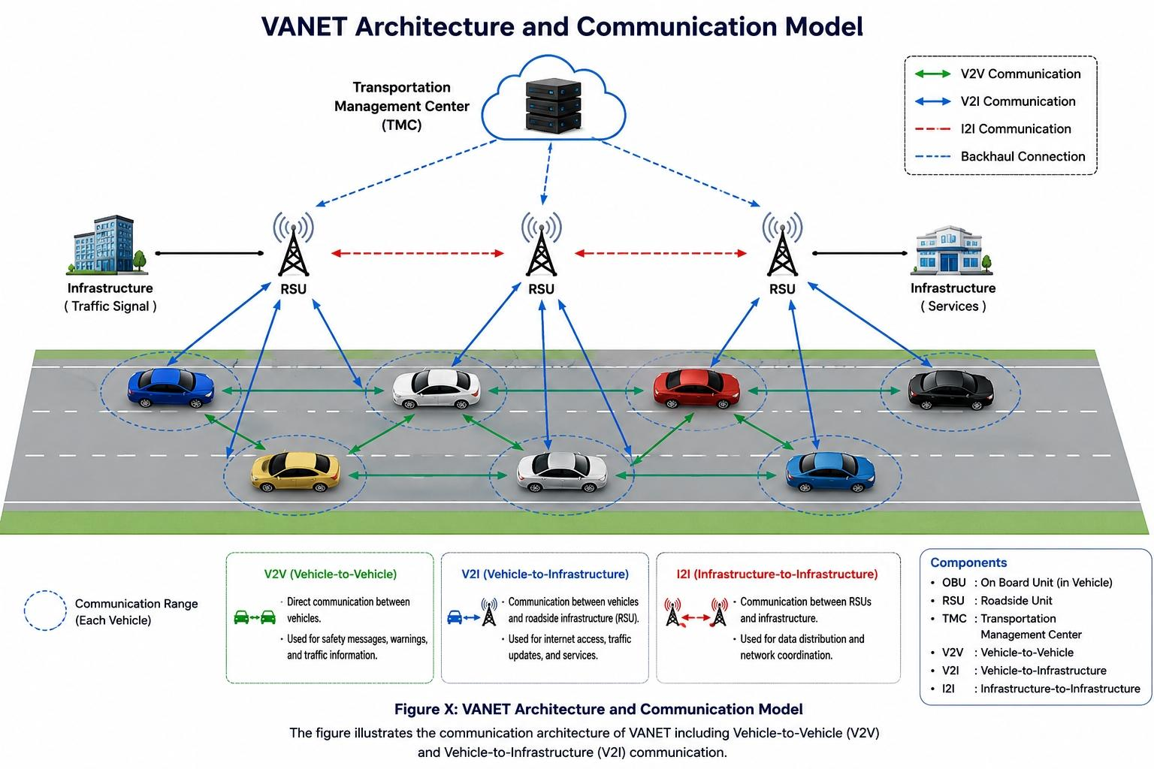

VANET Architecture Layers and Protocol Stack:

Vehicular Ad Hoc Networks (VANETs) rely on a layered communication architecture similar to the TCP/IP and IEEE communication models. Each layer is responsible for specific communication functions and utilizes dedicated protocols to ensure efficient and reliable data exchange between vehicles and infrastructure.

The proposed project adopts a practical VANET protocol stack implemented within the NS-3 simulation environment.

- Application Layer

The Application Layer is responsible for generating and processing vehicular communication messages related to road safety and traffic management.

In this project, customized application messages were implemented, including:

- BEACON messages
- SAFETY_ALERT messages
- TRAFFIC_STATUS messages
- SPEED_REPORT messages

These messages support real-time traffic awareness and attack simulation scenarios such as identity spoofing.

- Transport Layer

The Transport Layer is responsible for end-to-end communication between nodes and packet delivery management.
The project uses:

- UDP (User Datagram Protocol)
UDP was selected because VANET applications require:

- Low latency
- Fast message transmission
- Real-time communication

Although UDP does not guarantee reliable delivery, it is widely used in VANET safety applications due to its lightweight nature and minimal delay.

- Network Layer

The Network Layer manages routing and packet forwarding between vehicles and infrastructure nodes.

The routing protocol implemented in this project is:
- AODV (Ad hoc On-Demand Distance Vector)
AODV is a reactive routing protocol that dynamically discovers routes only when needed, making it suitable for highly dynamic VANET environments.
The protocol supports:

- Dynamic route discovery
- Route maintenance
- Efficient packet forwarding in mobile environments

- MAC and Physical Layer
The MAC and Physical Layers are responsible for wireless channel access and physical data transmission.
The project uses:

- IEEE 802.11-based wireless communication
- Wi-Fi Ad Hoc Mode
- IEEE 802.11-based vehicular communication in ad hoc mode

These technologies provide:
- Short-range wireless communication
- Fast channel access
- Support for high vehicle mobility

The physical communication environment was configured inside NS-3 to simulate realistic VANET wireless behavior.

Weaknesses of VANET Networks

Despite the significant advantages of Vehicular Ad Hoc Networks (VANETs), these networks suffer from several weaknesses and limitations that affect their performance, reliability, and security. These weaknesses mainly arise from the unique characteristics of VANETs, such as high mobility, dynamic topology, and the use of open wireless communication channels.

- High Mobility of Nodes

One of the primary weaknesses of VANETs is the high speed and continuous movement of vehicles. This leads to:

Frequent disconnections between nodes

Short communication durations

Difficulty in maintaining stable communication links

As a result, data transmission may be interrupted or delayed, which negatively impacts network reliability.

- Rapidly Changing Network Topology

The network topology in VANET changes continuously due to the movement of vehicles. This makes it difficult to:

Maintain consistent routing paths

Ensure stable communication links

Predict network behavior accurately

This dynamic environment increases the complexity of designing efficient routing protocols.

- Limited Communication Range

VANET relies on short-range wireless communication technologies such as Dedicated Short Range Communication (DSRC). This results in:

Limited network coverage

The need for a high density of vehicles or Road Side Units (RSUs)

Possible communication loss in low-traffic areas

- Security Vulnerabilities

Due to the open nature of wireless communication, VANET is highly vulnerable to various security threats, including:

Message tampering

Eavesdropping

Impersonation attacks

Denial of Service (DoS) attacks

These vulnerabilities can have serious consequences, especially in safety-critical applications.

- Privacy Issues

Vehicles in VANET continuously broadcast sensitive information such as location, speed, and identity. This creates several privacy concerns, including:

Tracking of vehicle movements

Exposure of user identity

Misuse of personal data

Ensuring user privacy while maintaining efficient communication remains a significant challenge.

- Scalability Challenges

As the number of vehicles increases, VANET faces scalability issues such as:

Increased network congestion

Higher packet collision rates

Reduced communication efficiency

These issues are particularly critical in densely populated urban environments.

- Dependence on External Systems

VANET depends heavily on external technologies such as GPS and RSUs. Any failure in these systems may lead to:

Inaccurate location information

Communication disruption

Degradation of overall network performance

- Lack of Standardization

Despite ongoing research and development, VANET still suffers from:

Lack of unified communication standards

Variations in protocols and technologies

Difficulty in interoperability between different systems.

Security Mechanisms in VANET Networks

Ensuring security in Vehicular Ad Hoc Networks (VANETs) is a critical requirement due to the open wireless communication environment and the safety-critical nature of the applications. Various security mechanisms have been developed to protect VANETs from potential attacks and to ensure reliable and trustworthy communication between vehicles.

- Authentication Mechanisms

Authentication is one of the fundamental security requirements in VANET. It ensures that only legitimate vehicles are allowed to participate in the network.

In VANET, authentication is typically achieved using digital certificates and cryptographic techniques. Each vehicle is assigned a unique identity and a corresponding cryptographic key, which is used to verify its authenticity.

This mechanism helps prevent attacks such as impersonation, where a malicious node attempts to act as a legitimate vehicle.

- Data Integrity

Data integrity ensures that the transmitted messages are not altered during transmission.

This is usually achieved using cryptographic hash functions and digital signatures. When a message is sent, a hash value is generated and attached to it. The receiver recalculates the hash and compares it with the received one to verify that the message has not been modified.

Maintaining data integrity is essential in VANET, especially for safety-related messages.

- Confidentiality

Confidentiality ensures that sensitive information is only accessible to authorized entities.

Encryption techniques are used to protect data from unauthorized access. Even if an attacker intercepts the message, they will not be able to understand its content without the correct decryption key.

- Non-Repudiation

Non-repudiation ensures that a sender cannot deny sending a message.

This is achieved using digital signatures, which provide proof of the origin of the message. This mechanism is important for accountability, especially in scenarios involving accidents or disputes.

- Privacy Preservation

Protecting user privacy is a major concern in VANET. Mechanisms such as pseudonyms are used to hide the real identity of vehicles.

Vehicles can use temporary identities that change periodically, making it difficult to track them while still allowing secure communication.

- Intrusion Detection Systems (IDS)

Intrusion Detection Systems are used to monitor network activity and detect suspicious behavior.

IDS can identify anomalies such as:

Unusual message patterns

Multiple identities used by a single node

Inconsistent location information

Once detected, appropriate actions can be taken, such as isolating the malicious node.

- Trust Management Systems

Trust-based mechanisms evaluate the behavior of nodes and assign trust levels accordingly.

Nodes with low trust values may be ignored or excluded from the network. This helps in identifying and mitigating malicious behavior over time.

- Secure Routing Protocols

To enhance security, secure versions of routing protocols have been developed, such as Secure AODV (SAODV).

These protocols incorporate security features like authentication and digital signatures to ensure that routing information is not manipulated by malicious nodes.

Security Challenges in VANET Networks

Vehicular Ad Hoc Networks (VANETs) face a unique set of security challenges due to their dynamic nature, open wireless environment, and critical applications. These challenges complicate the design of secure communication mechanisms and make VANETs vulnerable to a variety of attacks.

- High Mobility and Dynamic Topology

Vehicles move at high speeds, causing frequent network disconnections.

Rapidly changing network topology makes it difficult to establish and maintain secure routing paths.

Attackers can exploit temporary communication gaps to inject malicious messages.

- Open Wireless Communication

VANET relies on open wireless channels, which are easily accessible by attackers.

This exposes the network to eavesdropping, message tampering, and replay attacks.

Securing wireless communication without impacting performance is challenging.

- Scalability and Large Network Size

VANET can consist of thousands of vehicles in urban environments.

Maintaining security at scale is difficult due to the large number of nodes.

Cryptographic operations may introduce delays, affecting real-time communication.

- Authentication and Identity Management

Ensuring the authenticity of every vehicle is challenging.

Lack of proper identity management enables impersonation and Sybil attacks.

Managing digital certificates for all vehicles requires a robust infrastructure.

- Privacy Preservation

Vehicles continuously broadcast location and behavioral information.

Protecting user privacy while maintaining accountability is difficult.

Attackers can track vehicles if pseudonyms or anonymization techniques are not implemented properly.

.

- Real-Time Communication Requirements

Safety applications demand real-time data delivery.

Security mechanisms like encryption and authentication may introduce delays.

Balancing security and low-latency performance is a major challenge.

- Vulnerability to Insider Attacks

Compromised or malicious vehicles can bypass external security mechanisms.

Insider attackers are harder to detect than external threats.

Trust and reputation-based mechanisms must implemented to mitigate insider attacks

- Resource Constraints

Vehicles have limited computational power and memory.

Intensive cryptographic operations may impact performance.

Designing lightweight security mechanisms without compromising effectiveness is essential.

- Dependence on Infrastructure

VANET often relies on Road Side Units (RSUs) and central authorities.

Any compromise or failure of these components can weaken network security.

Ensuring distributed security without relying too heavily on infrastructure is a challenge.

- Heterogeneity and Standardization Issues

Different vehicle manufacturers may use different communication technologies.

Lack of standardized protocols complicates secure interoperability.

Ensuring consistent security across heterogeneous systems is difficult.

- Denial of Service (DoS) and Resource Exhaustion

Attackers can flood the network with fake messages to overload nodes.

This disrupts both safety and non-safety applications.

Detecting and mitigating DoS attacks in a highly dynamic network is challenging

- Integration with Emerging Technologies

VANETs are evolving to include V2X, autonomous vehicles, and IoT devices.

Integrating new technologies while maintaining security introduces additional risks.

New attack vectors appear as complexity increases.

The following table summarizes the main VANET protocol layers, their associated technologies, potential attacks, existing vulnerabilities, and their impact on network performance and security.

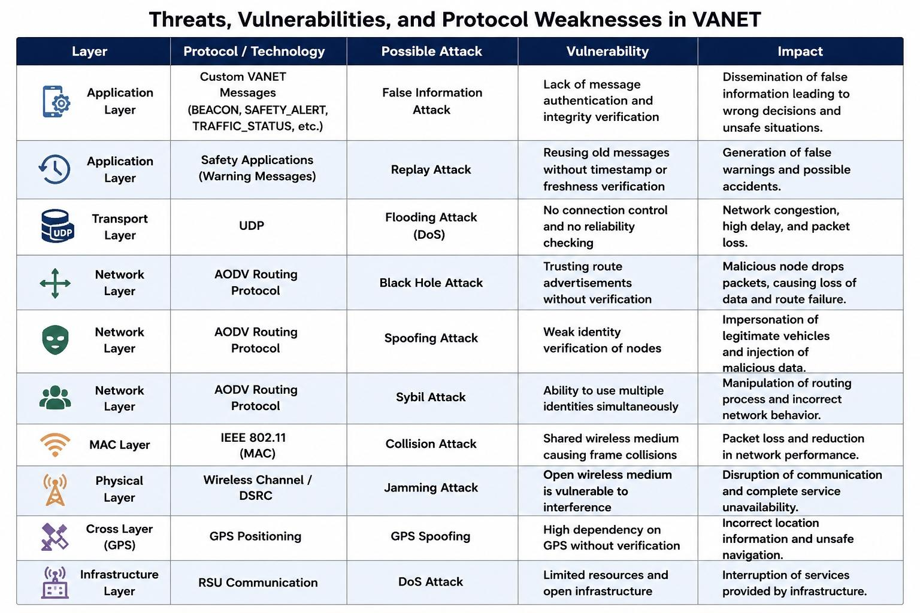

Chapter Two: Practical Implementation and Experimental Setup

2.0 Chapter Overview

This chapter presents the practical implementation of the proposed VANET security framework. It focuses on building a realistic simulation environment using NS-3 and SUMO, implementing an identity spoofing attack scenario, and evaluating its impact on network behavior. Furthermore, detection and mitigation mechanisms are introduced to enhance network security and reliability.

2.1 Simulation Environment

The experimental environment was built using a combination of simulation and visualization tools in order to create a realistic vehicular communication scenario. The main tools used in this project include:

- NS-3 as the network simulator

- SUMO (Simulation of Urban Mobility) for realistic vehicle movement generation

- Python with TraCI for integrating simulation output with visualization

- Ubuntu as the operating system platform

The VANET scenario supports both:

- Vehicle-to-Vehicle (V2V) communication

- Vehicle-to-Infrastructure (V2I) communication

The implemented network consists of:
- 40 vehicles
- 2 Road Side Units (RSUs)
Thus, the total number of nodes in the system is 42 nodes.

2.2 Network Configuration

The vehicular network was configured in NS-3 using a wireless ad hoc environment based on IEEE 802.11. Communication between nodes was established using Wi-Fi in ad hoc mode, while routing was handled using the Ad hoc On-Demand Distance Vector (AODV) protocol.

Key configuration features include:

- IEEE 802.11-based wireless communication

- AODV routing protocol

- Dynamic route discovery

- V2V and V2I communication support

- Custom application-layer communication using UDP sockets

Unlike basic UDP echo models, this implementation uses customized packet structures to better simulate realistic VANET traffic behavior.

Routing Protocol Selection:
AODV was chosen due to its low routing overhead and its ability to adapt dynamically to rapidly changing VANET topologies. Its reactive nature makes it suitable for highly mobile vehicular

2.3 Mobility Model and Traffic Simulation
Vehicle mobility was generated using SUMO, where a realistic traffic scenario was designed and exported as a movement trace file (positions.txt). This file was then used in NS-3 to replicate vehicle movement.

Inside NS-3, mobility updates were handled using scheduled events (Simulator::Schedule), ensuring synchronization between vehicle movement and network communication.

This integration improves realism by simulating communication between moving vehicles rather than static nodes.

2.4 Application-Level Message Design
To enhance realism, customized message types were implemented instead of generic packets. These messages include both networking and contextual traffic information.
The implemented message types include:

BEACON
SAFETY_ALERT
TRAFFIC_STATUS
SPEED_REPORT

Each message contains fields such as:

Sender
claimedId
speed
position (posX, posY)
event
priority
status

This structure allows detailed simulation of VANET communication and enables security analysis at the application level.

2.5 Attack Scenario: Identity Spoofing
The main attack implemented in this project is Identity Spoofing (ID Spoofing). In this attack, a malicious node falsifies its identity in transmitted messages to impersonate another vehicle.

In this scenario:

- The attacker node is vehicle19

- The attacker sends forged messages during runtime

- The claimed identity is falsified and changes dynamically

- Victim nodes vary across simulation runs

Spoofed packets are characterized by:

Sender = vehicle19
claimedId = forged identity

This mismatch represents the core of the spoofing attack.
The attack was applied to multiple message types, including:

- Fake collision warnings

- Fake emergency braking messages

- Fake speed reports

- Fake congestion alerts

2.6 Detection Mechanism

A lightweight detection mechanism was implemented based on identity verification.
The detection logic compares:
Actual sender (sender)
Claimed identity (claimedId)
A message is considered malicious if:
Sender ≠ claimedId
This condition enables real-time detection of spoofed packets.

2.7 Prevention and Mitigation Mechanism
After detecting malicious messages, a mitigation mechanism is applied to reduce the attack impact.

The system performs the following actions:
- Classifies the message as malicious

- Drops the spoofed packet

- Marks the attacker node as suspicious

- Records blocked attack attempts

This transforms the system into a detection and prevention model
2.8 Randomized Attack Parameters

To enhance realism, controlled randomness was introduced in the simulation.
The following parameters vary between runs:
- Spoofed identity

- Victim node

- Attack timing
This prevents repetitive results and simulates real-world unpredictable attack behavior.

2.9 Security Output and Attack Field Analysis
The simulation generates detailed output for analysis, including:
Message type

Sender identity

Claimed identity

Detection result

Prevention result
A dedicated “Attack Field Analysis” highlights the attack source:

The attack source:
Normal: sender = claimedId

Attack: sender ≠ claimedId
This improves clarity in both analysis and presentation.

2.10 Performance Evaluation Metrics
The system was evaluated using both network and security metrics.

Network metrics:

- Packet Delivery Ratio (PDR)

- Packet Loss

- Throughput

Security metrics:

Spoofed Messages Sent

Spoofed Messages Detected

Blocked Spoofed Messages

Detection Accuracy

Mitigation Rate

Detection accuracy is defined as:

Detection Accuracy = (Detected / Sent) × 100

Mitigation rate is defined as:

Mitigation Rate = (Blocked / Sent) × 100

2.11 Integration with SUMO Visualization
To improve visualization, the simulation was integrated with SUMO using Python and TraCI A file (attack_visual.txt) was generated to store:

Time

Vehicle ID

Role (Attacker, Victim, Spoofed, Blocked)

Vehicles were visually distinguished using colors:

Attacker → Red

Spoofed → Orange

Victim → Yellow

Blocked → purple

NS-3 generates an intermediate file named attack_visual.txt, which is then read by the Python TraCI script to visualize attacker, victim, spoofed identity, blocked node, and accident events dynamically inside the SUMO environment.

2.12 Visual Emphasis of Accident Scene

To highlight attack impact:

Accident markers are displayed

Vehicles involved are enlarged

Camera zoom is applied

Motion is slowed
This improves clarity during demonstrations.

2.13 Experimental Observations
The simulation demonstrates that VANET systems are vulnerable to identity spoofing when identity verification is absent.
However, the proposed detection and mitigation mechanism successfully:
Detects spoofed messages

Prevents malicious packet propagation

Reduces attack impact

2.14 Chapter Summary

This chapter presented the complete implementation of a VANET spoofing attack scenario using NS-3 and SUMO. A realistic environment was created with dynamic vehicle movement and customized communication messages.
An Identity spoofing attack was successfully simulated, and a lightweight detection and mitigation mechanism was implemented to identify and block malicious messages.
The results highlight the importance of identity verification and proactive security mechanisms in VANET environments.
The next chapter will present a detailed analysis of performance results and evaluate the effectiveness of the proposed approach.

Chapter Three: Results and Performance Evaluation

3.0 Chapter Overview
This chapter presents a comprehensive evaluation of the proposed VANET security framework under an identity spoofing attack scenario. The analysis focuses on measuring both network performance and security effectiveness before and after applying the detection and mitigation mechanisms. The results demonstrate the impact of spoofing attacks on network behavior and highlight the effectiveness of the proposed solution.

3.1 Evaluation Metrics
To assess the performance of the system, both network-related and security-related metrics were considered.
Network Performance Metrics

Packet Delivery Ratio (PDR): The percentage of successfully delivered packets to the total number of transmitted packets.

Packet Loss: The number of packets that fail to reach their destination.

Throughput: The rate of successful data transmission over the network.

Security Metrics

Spoofed Messages Sent

Spoofed Messages Detected

Blocked Spoofed Messages

Detection Accuracy

Mitigation Rate

These metrics provide a comprehensive evaluation of both communication efficiency and security performance

3.2 Attack Impact Analysis (Before Detection)
Before applying any detection mechanism, the spoofing attack has a significant negative impact on the network.
The attacker node is able to inject forged messages using fake identities, and since no verification mechanism is in place, these messages are treated as legitimate by other nodes.

This leads to several issues:

- Dissemination of false information (e.g., fake accidents or warnings)

- Incorrect responses from vehicles

- Increased packet loss

- Decreased Packet Delivery Ratio (PDR)

- Reduced network reliability

These results demonstrate that VANET environments are highly vulnerable to identity spoofing attacks in the absence of proper security mechanisms.

3.3 Detection Performance Analysis
After enabling the detection mechanism based on identity verification, the system is able to identify spoofed messages effectively.
The mechanism compares the sender field with the claimed identity field. If a mismatch is detected, the message is classified as malicious.
Detection Accuracy is calculated as:
Detection Accuracy = (Spoofed Messages Detected / Spoofed Messages Sent) × 100

The results indicate a high detection rate due to the effectiveness of the mismatch condition:
Sender ≠ claimedId

During experimental runs, the system successfully detected spoofed packets generated by the attacker node in real time. The mismatch condition between sender and claimedId provided a lightweight and efficient method for identifying malicious messages without introducing significant communication overhead.
This confirms that identity inconsistency is a reliable indicator for detecting spoofing attacks in VANET environments.

3.4 Mitigation Effectiveness
After detecting spoofed messages, a mitigation mechanism is applied to reduce the impact of the attack.
The system performs the following actions:
- Drops malicious packets

- Prevents further propagation of spoofed messages

- Marks the attacker node as suspicious

- Mitigation Rate

Mitigation Rate is calculated as:
Mitigation Rate = (Blocked Spoofed Messages / Spoofed Messages Sent) × 100

The results show that most spoofed packets are successfully blocked, significantly reducing the impact of the attack.

In several simulation runs, spoofed warning and traffic messages were blocked before reaching neighboring vehicles, which helped reduce the spread of false information across the VANET environment.

3.5 Network Performance Analysis (After Protection)
After applying detection and mitigation mechanisms, the network performance shows clear improvement:
Packet Delivery Ratio (PDR) increases

Packet loss decreases

Throughput becomes more stable

Overall network reliability improves
Although the detection mechanism introduces slight processing overhead, the improvement in security and stability outweighs this cost.

The experimental observations indicate that applying lightweight spoofing detection improves network stability while maintaining acceptable communication performance in highly dynamic vehicular environments.

3.6 Comparative Analysis
A comparison between the system performance before and after applying the security mechanism is shown below

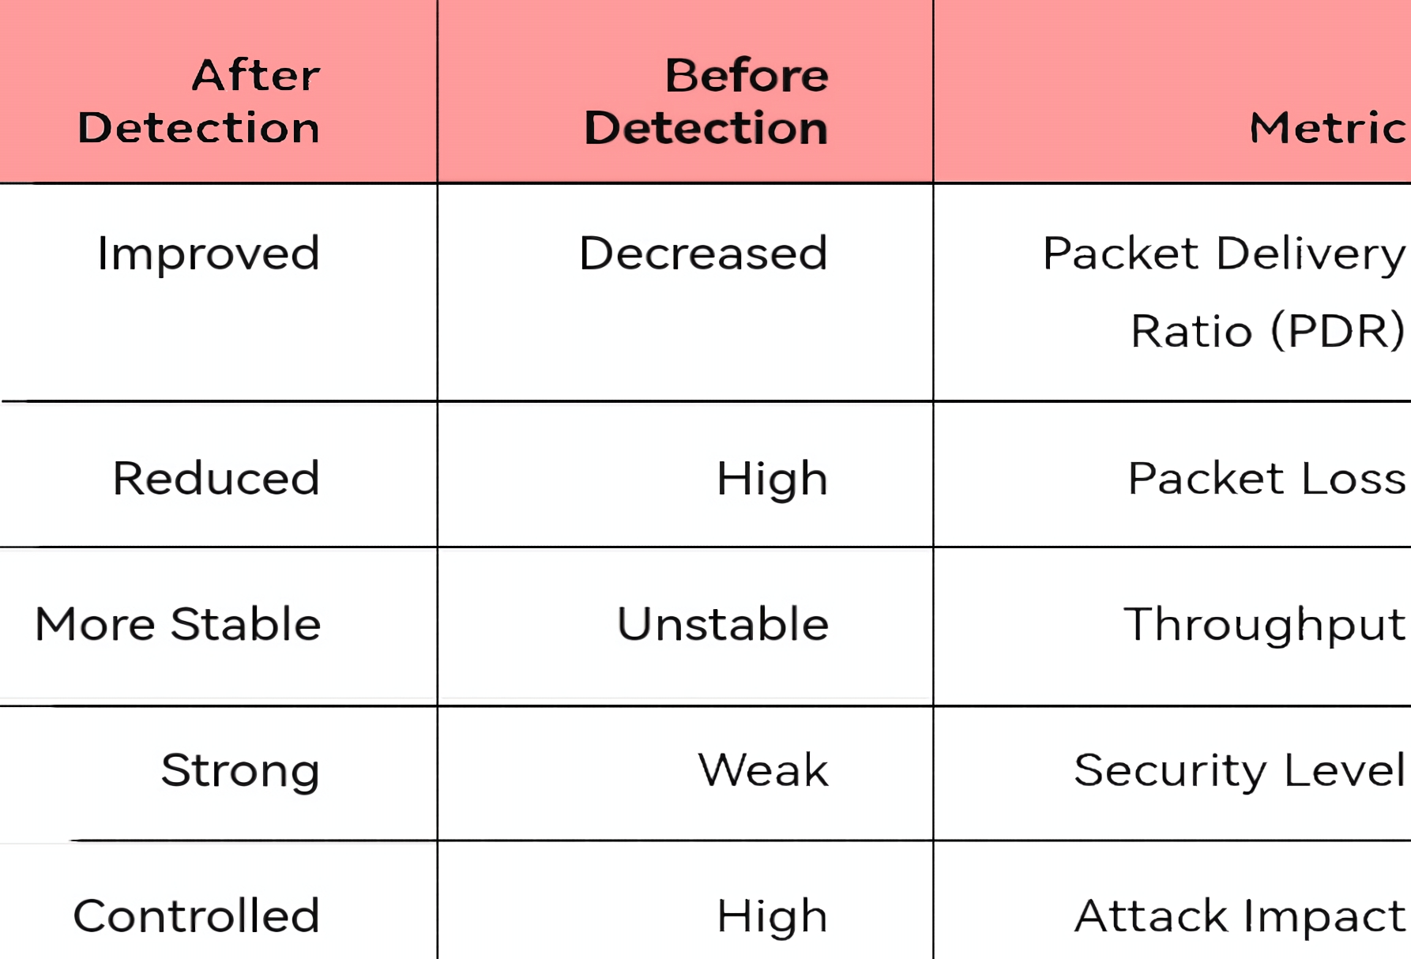

This comparison clearly demonstrates the effectiveness of the proposed detection and mitigation approach.

Chapter Four: Discussion and Comparative Analysis

4.0 Chapter Overview

This chapter provides a critical discussion of the experimental results and compares the proposed VANET security approach with existing studies in the literature. It highlights the strengths and limitations of the implemented system and evaluates its contribution in addressing current research gaps.

4.1 Discussion of Results

The results obtained from the simulation clearly demonstrate that identity spoofing attacks can significantly degrade the performance and reliability of VANET systems when no security mechanisms are applied.

The attack leads to:

- Dissemination of false information within the network
- Incorrect decision-making by vehicles
- Degradation of communication efficiency

After applying the proposed detection and mitigation mechanisms, a noticeable improvement is observed in both network performance and security.

The detection mechanism, which is based on identity mismatch, proves to be:

- Effective in identifying spoofed messages
- Fast in execution
- Suitable for real-time environments

In addition, the mitigation mechanism enhances the system by preventing malicious packets from propagating through the network, thereby reducing the overall impact of the attack.

4.2 Comparison with Existing Studies

The proposed approach can be compared with previous research studies discussed in Chapter One.

Traditional Security Approaches

Earlier studies mainly relied on:

- Cryptographic authentication
- Certificate-based identity verification
- Secure routing protocols

Although these approaches provide strong security guarantees, they often introduce:

- High computational overhead
- Increased communication latency
- Scalability issues in large networks
- Modern Intelligent Approaches

Recent research has focused on more advanced techniques, including:

- Machine learning-based intrusion detection systems
- Federated learning approaches
- Artificial intelligence-based anomaly detection

These methods offer:

- Higher detection accuracy
- Better adaptability to dynamic environments

However, they also require:

- Large datasets for training
- High computational resources
- Complex implementation and deployment

Proposed Approach Contribution
The approach presented in this project differs in several aspects:
- It uses a lightweight and rule-based detection mechanism
- It does not depend on complex infrastructure
- It operates efficiently in real-time environments

This makes it more practical for real-world VANET scenarios where low latency and simplicity are critical.

4.3 Strengths of the Proposed System

The proposed system demonstrates several important strengths:

- Simple and efficient implementation
- Low computational overhead
- Real-time detection capability
- Effective mitigation of spoofing attacks
- Integration with realistic simulation tools (NS-3 and SUMO)

Additionally, the use of visualization techniques enhances the clarity of the attack behavior and improves the presentation of results.

4.4 Limitations

Despite its advantages, the proposed system has some limitations:

- It relies on a simple rule-based detection mechanism
- It focuses mainly on identity spoofing attacks
(The implemented practical attack scenario in this project primarily targets Identity Spoofing attacks within VANET environments.)
- It does not incorporate advanced machine learning techniques
- It may be less effective against complex or coordinated attacks (such as Sybil attacks)

These limitations indicate areas for further improvement and development.

4.5 Summary

This chapter presented a detailed discussion of the system performance and compared the proposed approach with existing solutions.

The results confirm that the proposed method offers a practical and efficient solution for detecting and mitigating identity spoofing attacks while maintaining low computational cost and real-time

Chapter Five: Conclusion and Future Work

5.0 Chapter Overview

This chapter summarizes the main findings of the project and outlines potential directions for future improvements and research.

5.1 Conclusion

This project investigated the security challenges in Vehicular Ad Hoc Networks (VANETs), with a particular focus on identity spoofing attacks.

A realistic simulation environment was developed using NS-3 and SUMO to model communication between vehicles in a dynamic environment.

The project successfully achieved the following:

- Simulation of an identity spoofing attack
- Analysis of its impact on network performance
- Implementation of a detection mechanism based on identity verification
- Application of a mitigation strategy to reduce attack impact
- Evaluation of system performance using multiple metrics

The results clearly indicate that spoofing attacks can significantly degrade network performance and reliability when no protection mechanisms are applied.

However, the proposed detection and mitigation approach proved to be effective in:

- Identifying malicious messages
- Preventing the propagation of spoofed packets
- Improving overall network performance

These findings emphasize the importance of integrating efficient and lightweight security mechanisms into VANET systems.

5.2 Future Work

Although the proposed system achieved promising results, several enhancements can be considered in:

- Developing machine learning-based detection mechanisms
- Extending the system to support additional attack types such as:
Sybil attacks
Denial of Service (DoS) attacks
- Improving detection accuracy and reducing false positives
- Testing the system in larger and more complex network scenarios
- Integrating blockchain technology for secure identity management
- Enhancing system performance in high-density traffic environments

Table of Contents

Chapter One: Theoretical Studies

1.1 Introduction …………….. 2

1.2 Scientific Problem …………….. 3

1.3 Research Objective …………….. 3

1.4 State Of The Art …………….. 4

1.5 VANET Mechanism …………….. 11

1.5.1 Components of VANET (OBU, RSU, Vehicles) …………….. 12

1.5.2 Types of Communication (V2V, V2I, V2X) …………….. 13

1.5.3 Data Exchange and Routing Protocols …………….. 13

1.6 VANET Architecture and Protocol Stack …………….. 17

1.7 Weaknesses and Limitations of VANETs …………….. 20

1.8 Security Mechanisms in VANETs …………….. 23

1.9 Security Challenges and Threats …………….. 26

Chapter Two: Practical Implementation and Experimental Setup

2.0 Chapter Overview …………….. 41

2.1 Simulation Environment (NS-3 & SUMO) …………….. 42

2.2 Network Configuration and Routing (AODV) …………….. 43

2.3 Mobility Model and Traffic Simulation …………….. 44

2.4 Application-Level Message Design …………….. 44

2.5 Attack Scenario: Identity Spoofing …………….. 45

2.6 Detection Mechanism …………….. 47

2.7 Prevention and Mitigation Mechanism …………….. 47

2.11 Integration with SUMO Visualisation …………….. 51

Chapter Three: Results and Performance Evaluation

3.1 Evaluation Metrics (Network & Security) …………….. 54

3.2 Attack Impact Analysis (Before Detection) …………….. 55

3.3 Detection Performance Analysis …………….. 56

3.4 Mitigation Effectiveness …………….. 57

3.5 Network Performance Analysis (After Protection) …………….. 58

3.6 Comparative Analysis …………….. 58

Chapter Four: Discussion and Comparative Analysis

  - Discussion of Experimental Results …………….. 61

  - Comparison with Existing Studies …………….. 62

4.3 Strengths and Limitations of the Proposed System …………….. 64

Chapter Five: Conclusion and Future Work

5.1 Conclusion …………….. 66

5.2 Future Work and Recommendations …………….. 67

5.3 References …………….. 73

References

[1] M. A. Mahmoud et al., “Security in Vehicular Ad Hoc Networks: Challenges and Countermeasures,” Wireless Communications and Mobile Computing, vol. 2021, Article ID 9997771, 2021.

[2] Y. Yoshizawa et al., “A Survey of Security and Privacy Issues in V2X Communication Systems,” arXiv preprint arXiv:2208.14674, 2022.

[3] “Ensuring Security and Privacy in VANET: Authentication Approaches,” Wireless Communications and Mobile Computing, 2024.

[4] “State-of-the-Art Authentication and Verification Schemes in VANETs: A Survey,” Internet of Things Elsevier, 2024.

[5] “Enhancing VANET Security: An Unsupervised Learning Approach for Mitigating False Information Attacks in VANETs,” Electronics, vol. 14, no. 1, 2025.

[6] “Intrusion Detection System for V2X Communication in VANET Networks Using Machine Learning-Based Cryptographic Protocols,” Scientific Reports, Nature, 2024.

[7] “A Secure and Efficient Blockchain Enabled Federated Q-Learning Model for Vehicular Ad-hoc Networks,” Scientific Reports, Nature, 2024.

[8] “Augmenting Vehicular Ad Hoc Network Security and Efficiency with Blockchain: A Probabilistic Identification and Malicious Node Mitigation Strategy,” Electronics, vol. 12, no. 23, 2024.

[9] “Security in V2X Systems,” Computer Communications, Elsevier, 2024.

[10] IEEE Conference Paper, “Vehicular Network Security and Authentication Mechanisms,” IEEE Xplore, Document ID: 9522170, 2021.

